per the CWA 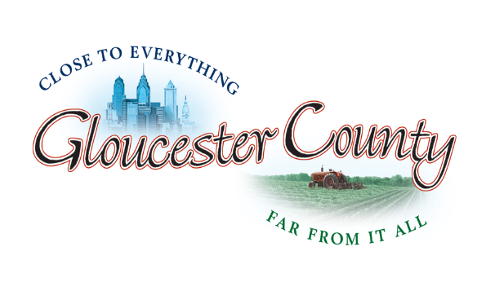

BOARD OF
COUNTY COMMISSIONERS

COUNTY OF GLOUCESTER
STATE OF NEW JERSEY

DIRECTOR
Frank J. DiMarco

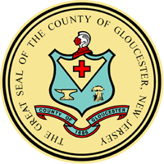

BOARD OF TAXATION

Lou Sebastiani, President
Bradley A. Blubaugh
Elizabeth Rogale
Justin Kolman

Clayton Complex, Bldg. A
1200 N. Delsea Drive
Clayton, NJ 08312

Phone 856-307-6448
Fax 856-307-6419
cprus@co.gloucester.nj.us

www.gloucestercountynj.gov

The County of Gloucester complies with all state and federal rules and regulations against discrimination in admission to, access to, or operations of its programs, services, and activities. In addition, County encourages participation of people with disabilities in its programs and activities and offers special services to all residents 60 years of age and older. Inquiries regarding compliance may be directed to the County’s ADA Coordinator at (856) 384-6842/ New Jersey Relay Service 711.

GLOUCESTER COUNTY
BOARD OF TAXATION MEETING SCHEDULE
2025-2026

Apr 29, 2025 -Re-organization- Clayton
May13, 2025-Preliminary Equalization-Clayton
May 20, 2025-Final Equalization-Clayton
Sep 23, 2025-Farmland Roll-Back Hearing-Clayton
Oct 07, 2025-Compliance Plans-Clayton-
Dec 16, 2025-Added/Omitted Hearing - Clayton
Mar 24, 2026-Regular Meeting-Clayton
Apr 28, 2026 Re-Organization - Clayton
May 12, 2026-Preliminary Equalization-Clayton
May 19, 2026-Final Equalization-Clayton

CLAYTON COMPLEX
1200 NORTH DELSEA DRIVE
BUILDING A
CLAYTON, NJ 08312
AUDITORIUM AT 8:30 AM

Please call the Tax Board Office at 856-307-6448 to obtain location or by phone meeting call in code.

