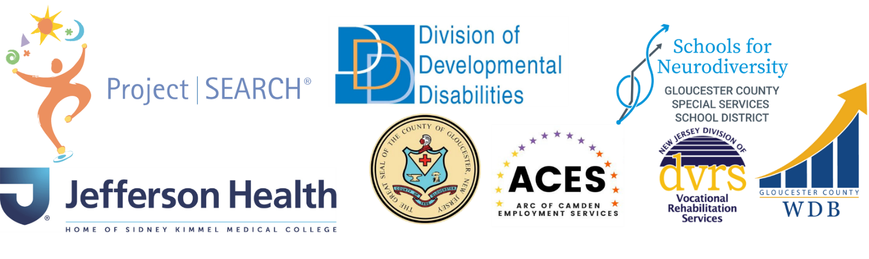

Thank you for your interest in Project SEARCH!
Project SEARCH is a transition to work program that lasts for one school year. The program serves young adults with intellectual and developmental disabilities that need an intensive year of career development, internship experience, and support to reach their goals. The program embraces interns that have other disabilities (such as: physical and mental health disabilities) and challenges (such as: poverty and homelessness) as well.

To apply you must be:
- At least 18 years old
- On an IEP
- Eligible for Vocational Rehabilitation (VR) services
There are 4 steps to the process.
Step 1: You and your parent / guardian must complete this application. Then you must mail or email it.
Justin Dickerman
jdickerman@gcecnj.org or mail to:
Steve Sweeney Building
530 Salina Road
Sewell, NJ 08080
Deadline: ONGOING

Step 2: The Project SEARCH Selection Team will:
- Gather documents and information from the school and other agencies.
- Review these and consider your strengths, needs, and eligibility.
- Decide if you can move forward in the process.
- Inform you and your parent / guardian of next steps.

Step 3: If you are eligible to move forward, you must participate in the Skills Assessment Day.
- This is on (TBD) from 9am-12pm at Jefferson Hospital. We will give you more details about this later.
Step 4: The Selection Team will:
- Review the Assessment Day Results and prior information, and then select the interns for the upcoming school year.
- Contact you and your parent / guardian to let you know if you were accepted.

Project SEARCH Application
Please fill out this form. Your parent / guardian and someone from your school can help you, if needed. Before you fill out this form, please attend an information session, tour the program, and watch this video about Project SEARCH: (https://www.youtube.com/watch?v=8juNYG6nP1U).
Contact Information
- Student/Applicant
Name:__________________________________________________
Home Address:______________________________________________
Phone Number(s):___________________________________________
Email:_____________________________________________________
Birthday:___________________________________________________
- Parent / Guardian
Name: _____________________________________________________
Home Address:_______________________________________________

Phone Number(s):___________________________________________
Email:_____________________________________________________
- Parent / Guardian
Name: ____________________________________________________
Home Address:______________________________________________
Phone Number(s):____________________________________________
Email:______________________________________________________
- Is someone helping you fill out this form? ☐ Yes ☐ No
- If yes, please list their name and email or phone number here:
_____________________________________________________
Guardian
- Are you your own legal guardian? ☐ Yes ☐ No
- If no, what is the name of your legal guardian? _________________________
Education History
- What is your current high school? _____________________________________
- What is your current teacher’s name? _________________________________
- What is your current teacher’s email? __________________________________
- Will you have finished 4 years of high school at the end of this school year?
☐ Yes ☐ No
- Do you plan to graduate from high school at the end of Project SEARCH? ☐ Yes ☐ No

Work History
- Use the chart below to list any volunteer work, non-paid training, and paid work you have had.
Workplace | Dates of work | Work duties | Non-paid or paid?
The goal of Project SEARCH is for you to get a job where you:
- Work in an integrated setting. This means you work with people with and without disabilities.
- Are paid the typical wage for the job.
- Work at least 16 hours each week (with the goal to work full time)

- Are you willing to work 16 or more hours a week in an integrated setting after you finish Project SEARCH? ☐ Yes ☐ No
- Where would you like to work after you finish Project SEARCH?

- Does your family support your work goals? ☐ Yes ☐ No
Eligibility for Other Services
- Have you been approved for services with the NJ Division of Vocational Rehabilitation Services (DVRS)? ☐ Yes ☐ No
- If so, who is your counselor?
- If not, have you applied? ☐ Yes ☐ No
- If you have not applied, please see attached Referral form to apply.
- Have you been approved for long term adult support? ☐ Yes ☐ No
- If so, which program did you choose?
- If so, who is your case manager?
- If not, have you applied? ☐ Yes ☐ No
- If you have not applied, please reach out to: ddd.transitionhelpdesk@dhs.nj.gov

Personal Statement (Answer the Questions Below)
(If this section is scribed, please write the exact words used by the student. Use as much space as needed.)
- Why do you want to be a Project SEARCH intern?
____________________________________________________________________________________________________________________________________________________________________________________________________________________________________________________________________________________________________________
- What do you want us to know about you?
____________________________________________________________________________________________________________________________________________________________________________________________________________________________________________________________________________________________________________
- How did you find out about Project SEARCH?
____________________________________________________________________________________________________________________________________________________________________________________________________________________________________________________________________________________________________________
Release of Information
After looking at this form, the Steering Committee will reach out to your school and agency contacts. They will ask for other information to get to know you better.
This will include:
- Education documents such as: Evaluation Team Report (ETR), Individualized Education Program (IEP), attendance and health records, assessments
- VR documents such as: Individualized Plan for Employment (IPE), other assessments
- Long term support documents such as: a functional screen
- You and your parent / guardian will need to sign the accompanying “Release of Information” form. Do you have any concerns about this release of information?
Project SEARCH Intern Agreement
You and your parent / guardian will need to sign this agreement if you are accepted into the program.
I, (insert name here), understand that if I am accepted into the Project SEARCH program
- I will complete at least 3 unpaid internships at Jefferson Hospital
- I will attend the program every day from 8:00 am- 2:30 pm (this is subject to change).
- I will follow the dress code and arrive looking clean and neat.
- I will contact my instructor and mentor when I am absent or tardy.
- I will make up any assignments I miss if I am absent.
- I will follow all the rules of Jefferson Hospital and of the Project SEARCH program.
- I will attend all meetings with my counselor, parent / guardian, teacher, skills trainers, and business staff.
- I will participate in and discuss any issues at my meetings.
- I will actively look for a job that is 16 hours a week or more in an integrated setting.
- I understand that I must provide:
Immunization records
IGRA blood test (TB test)
COVID immunizations and booster
Influenza immunization
Background Check

I have read the statements above. I agree to these terms. I accept my placement in the Project SEARCH program. I understand that I may be asked to leave Project SEARCH if I do not follow these terms.
- Do you or your parent / guardian have any concerns with needing to sign this if you are accepted? ☐ Yes ☐ No
Thank you! We will email you to let you know we got your application.

Revised: 8/19/2025

